KeaExpert – Pulse Programming Guide

Version 2.02 (FX3) August 2025

Table of Contents

1 Introduction 2

2 File organisation 5

3 The Proton experiment examined 6

3.1 The Pulse Program Macro 8

3.2 The interface description 9

3.3 The relationships list 12

3.4 Understanding the various frequencies defined in an Expert 14

3.5 The group list 15

3.6 The variable list 16

3.7 The pulse program 16

3.8 The phase cycle matrix 17

3.9 The returned variables 17

3.10 How parameters are initialised in the user interface 17

4 Writing a new pulse program 19

5 The Experiment Control Macro 20

5.1 The execpp (execute pulse program) procedure arguments 21

5.2 The execpp procedure in detail 23

5.3 Modifying the execpp procedure to vary the pulse duration 25

Appendix A Pulse program commands 32

A.1 Acquire NMR data 32

A.2 Clear the spectrometer data memory 33

A.3 Delay for a specified time 34

A.4 Frequency modifications 34

A.5 Looping 35

A.6 RF pulse production 36

A.7 Shim and gradient commands 39

A.8 Table commands 40

Appendix B Available control groups 40

B.1 Acquisition 41

B.2 AcquisitionBW 41

B.3 AcquisitionBW2D 42

B.4 AcquisitionFIR 42

B.5 Display_Std 43

B.6 Display_2D 43

B.7 Display_Hz 43

B.8 File_Settings 44

B.9 Jres_processing 44

B.10 Processing_std 44

B.11 Processing2d_std 44

B.12 Processing_autophase 45

B.13 Processing_filter_autophase 45

B.14 ProcessingBW 45

Appendix C Procedures to change pulse program values 46

Appendix D Acquisition Explained 46

Appendix E Using Tables 47

Appendix F Programming multi-X spectrometers 49

Appendix G The pulse program event-table format 50

Appendix H Repetition or inter-experiment time? 51

Appendix I Spectrometer factory parameters 53

Appendix J The SpinsolveExpert classes 55

Appendix K Pulse program limits 56

Appendix L Exporting to MNova 56

Appendix M An introduction to Prospa programming 57

M.1 Data types 58

M.2 Variables 58

M.3 Control statements 59

M.4 Procedures 59

M.5 Commands 60

M.6 Debugging 61

M.7 Expressions 61

M.8 Matrices and vectors 61

M.9 User interface objects 62

M.10 Using the Prospa text editor 63

M.11 Additional help 63

# Introduction

This manual will help you to understand and write pulse programs for the SpinsolveExpert application. This version targets version 2.02 which can drive either legacy DSP based Spinsolves or those with the newer FX3 processors. The software interface is the same for both systems however there are some subtle differences which may be important. This documentation is for FX3 based systems.

The NMR pulse program controls a series of electronic modules in the spectrometer in such a way as to generate the desired NMR signal. At a minimum, this means producing radio frequency (RF) pulses of a specific amplitude, phase, frequency and duration at precise times, and then after a certain delay the NMR signal is captured and returned to the computer for processing and display. In addition, there may be control of digital (TTL) levels and magnetic field gradients or shims. If good quality data is to be collected, all of these functions must be applied at very specific times, with high precision and stability.

The Spinsolve spectrometers during and since 2023 use a FX3 CPU from Cypress to provide an interface between the controlling PC and the spectrometer pulse sequencer which resides on an FPGA (field programmable gate array) in the transceiver module.

The action of the pulse sequence is quite simple:

Perform an action

Wait a certain time

Perform next action

Wait a certain time

…

The high-level language used to represent this sequence is called the *pulse program*. A simple example is the SpinEcho experiment

pulse(a90, p1, d90)

delay(d1)

pulse(a180, p2, d180)

delay(d2)

acquire('overwrite', nrPnts)

Here you can see commands for generating RF pulses, adding a delay and acquiring the data. The parameters such as a90, d90, d1 and d2 etc must all be calculated independently of the sequence to function as expected. Much of the complexity of coding a sequence correctly comes from determining these parameter values.

The code for translating the high-level language used for pulse programming down to the machine code require by the FPGA is stored in the file called fx3PPRun.dll (a dynamic linked library), which is stored in the Expert/Prospa DLLs folder. The DLL includes translation information for some 50 commands used for controlling the spectrometer. However, of these, only a handful are commonly used. These are:

acquire .. collect NMR data

delay .... wait a certain number of microseconds.

pulse .... generate an RF pulse (or pulses) of specific amplitude, phase, duration and optionally frequency.

loop ..... repeat a section of code a number of times.

endloop .. define the end of the looped region

shim16 ... set the current in one of the spectrometer shims.

txon ..... switch on the RF

txoff .... switch off the RF

A more comprehensive list may be found in Appendix A.

All pulse programs must be surrounded by two other commands initpp and endpp

initpp

…

endpp

You can see more complete information about each command by typing:

> help command_name

at the command line (CLI) prompt or by pressing F1 when the insertion point is on the command name (this is valid for all Prospa commands).

When a pulse program is generated on the PC, each of these commands will produce a block of *event table code* which will be stitched together by the endpp command. The initpp command has an argument which specifies some additional parameters required for the pulse sequence generation (such as the default NMR frequencies and the digital filter parameters).

The event table is a list of events or commands which will be executed on the spectrometer at specific times. The format of each command is:

event_duration, event_command, event_parameters

Note that we specify a duration for each event rather than a specific time. This more closely matches the way the pulse program is defined at a higher level and makes it easier to insert new events without changing all the other times. Some pulse program commands such as *delay* result in a single event, while others such as *pulse* produce several.

Note that the event parameters are stored with the event command rather than separately as was the case with the older DSP based spectrometers.

We will not be concerned here about the details of the event table but rather how to construct the higher-level pulse programming language. For those interested in the format of the table (sometimes useful for debugging problems) please see Appendix XX.

The parameters for each pulse program command can be of two kinds:

* Fixed – this means the command will always use this parameter value e.g.

pulse(1, 16383, 0, 10).

This will produce a full power pulse on channel 1 with phase 0 for 10 µs using the currently defined transmitter frequency. In this case you may need to know the conversion algorithm for the argument value to convert from user to digital units.

* Variable – in this case the parameters are variable names which will later be given the desired values e.g. pulse(1, a1, p1, d1). The names of these variables are important – the first letter corresponds to the type of the parameter according to this table

aXXX ... An RF pulse amplitude in dB.

pNNN ... A phase in degrees/90

dXXX ... A delay in microseconds

fXXX ... A frequency in MHz.

nXXX ... An integer number

tXXX ... A table of numbers

Here XXX can be any valid Prospa variable name or an integer and NNN is an integer starting from 1. The phase numbers should be sequential (i.e. p1, p2, p3).

The use of special first characters means the system automatically knows how to convert from user units (e.g. dB for RF amplitude) to system units (in this case a 14 bit integer).

Before a pulse program can be run, the compiled event table with parameters is sent to the spectrometer and stored in the FPGA memory.

# File organisation

Experiments are typically grouped together, first based on the nucleus and then on the experiment name. Several files are required to run an experiment on the Spectrometer.

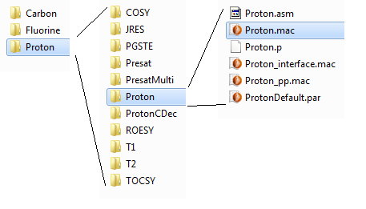

All of these files are stored in an experiment folder – ‘Proton’ in this case.

Each of these files has a particular purpose (for other experiments the name ‘Proton’ will be replaced by the experiment name):

Proton.mac ................. the experiment control macro. This contains the code to start the experiment, collect and display the data and it also includes loops to accumulate scans or change parameters if it is a multidimensional experiment.

Proton_interface.mac .. this defines the experiment user-interface as it will appear in the SpinsolveExpert application. It defines which parameters are visible, how the plot layout is organised and what post processing options are available. Part of this is automatically generated.

Proton_pp.mac ........... this defines the pulse program and parameters which are visible to the end user. It includes a table which defines the relationship between the user parameters and pulse program parameters. It also defines the phase cycling matrix for the experiment. This macro is only executed during the compilation phase.

Proton.asm ................. this file is only used by DSP based spectrometers and is ignored by the FX3 system.

Proton.p ...................... this file is only used by DSP based spectrometers and is ignored by the FX3 system.

ProtonDefault.par ........ this contains most of the parameters used in the experiment, with sensible values which should allow the experiment to run ‘out of the box’. Notice that some the parameters here such as B1 frequency, pulse lengths and powers, so called common or factory parameters, may be overwritten after the file is loaded into Expert since they depend on the particular Spectrometer you are using. This latter information is read from a FLASH memory block stored on the spectrometer FX3 flash memory.

Other files or folders which may be present

Proton_importStdData.mac ..... this file is used to import data collected using the Magritek standard software. It includes code to add missing parameters, transform and display the data. This will add a small button to the dividers in the parameter list.

ProtonParHelp.mac ………………. A help file for the parameter list which will be displayed in the Expert CLI. To activate this, you need to set the flag self-showParHelp = 1 in the init procedure of the file seParam.mac.

parameterVisibility.mac ………… Defines which parameters will be displayed if the option ‘Show user defined parameter entries’ is selected from the Experiment menu.

MNova ………………………………….. A folder containing information for importing an Expert data set into MNova. Apart from the logo, all files should have the same basename; e.g. Proton.qs, Proton.mnova, Proton.mnp. Please refer to the MNova section xxx for more details.

# The Proton experiment examined

To understand how experiment are written and executed we will now look at the most basic experiment, ‘Proton’, in more detail.

To view the various experiment files, select the experiment from the appropriate menu (e.g. 1H) holding down the shift key at the same time. Alternatively, if the experiment is visible in the history or batch lists press the enter key or select the option ‘Edit current pulse program’ from the history list contextual menu. Finally, you can also access the pulse program editor from the options in the ‘Experiment’ menu. Either with the option ‘Edit current protocol (Ctrl-Shift-P), or if you choose the option ‘Open pulse program editor’ then it will open with a blank interface.

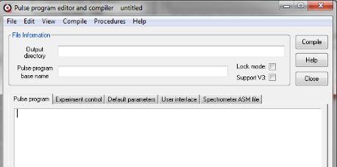

Then you can select the pulse program to load from the File->Open Pulse Program menu option (Ctrl+O).

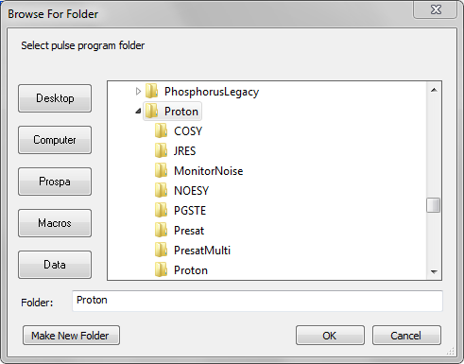

With the Proton folder selected, press the OK button or press Enter. By default, this will open the Experiment control macro ‘Proton.mac’.

This method is useful if the experiment will not load correctly, perhaps due to a bug in a file, when selecting from the menu.

The other important macros associated with the experiment are accessible from the different tabs above the editor. The name of the currently displayed file is visible in the title bar.

Two important file locations are given; the folder the pulse program files are in (Pulse program base name) and the parent directory (Output directory).

The Lock mode check box is used when compiling lock associated pulse programs (which for most users will be never), while the user interface (U.I.) version should be set to 5.

## The Pulse Program Macro

We will start by looking at the pulse-program macro. Click on the pulse program tab:

This macro contains the procedure *pulse*_*program*. It has three arguments, ‘dir’ which a data structure containing important parameters for initialising the sequence (the name is a hangover from the DSP based system which passed a directory to the initpp command), and ‘mode’ which is the particular pulsing mode. The third parameter ‘pars’ is the list of pulse program parameters. The ‘mode’ argument will always be ‘1’, standing for channel 1 (the proton channel). ‘mode’ is a carry-over from the Kea spectrometer which could have internal or external RF amplifiers. For Spinsolve applications you won’t need to use ‘mode’ and you should explicitly specify which channel you wish to access. However, for backward compatibility this line should not be modified.

The procedure is broken into several parts; the interface description, the relationships list and optional group interface, the variables list, the pulse program and the phase cycling matrix. We will look at each of these in turn.

## The interface description

The interface is described by a Prospa 2D list[1], each row of which describes one user interface element and label. Note that the last symbol on each row (except in the very last row) must be a semicolon. As an example, the first two rows in Proton are shown below:

interface = ["nucleus", "Nucleus", "tb", "readonly_string";

"b1Freq1H", "B1 Frequency (MHz)", "tb", "freq";

These define the nucleus and the B1 NMR frequency for protons. These generate the first two entries in the Expert Proton parameters user interface.

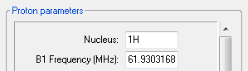

For each parameter, the interface list entries are; variable name, interface label, type of user interface element (or control) and some special information about the entered data (data type). The abbreviations in column 3 are defined below.

tb ...... a **t**ext entry (**b**ox) field

tm ...... a **t**ext **m**enu (a text entry field with a pull down menu)

cb ...... a **c**heck **b**ox

rb ...... **r**adio **b**uttons

bt ...... a standard **b**u**t**ton

dv ...... a line with a label to **d**i**v**ide controls into groups

Note that 3 letter symbols are sometimes used, but they are only relevant in V3 interface (e.g. ‘w’ makes the control wider, however all Expert text entry fields are already wide). However in some cases you can append ‘_wide’ to the tb or tm to make and extra wide interface (see ArrayExperiment in scripts menu)

The data type field can take a number of different parameters and formats:

array .......... the input should be a two-element array e.g [2,10]

double ......... a general double precision floating point number.

float ........... a general single precision floating point number.

freq ............ we expect the entry to be a frequency in MHz. This makes it double precision and it must fall within a certain range of values as define in the Spinsolve preferences file (5-110 MHz).

integer ......... a general positive integer number [1 ... 1e8].

ldelay .......... a long delay. For use with the wait command. This can range from 2 µs to 167 seconds. Units default to microseconds.

ldelayms ........ a long delay[2]. For use with the wait command. This can range from 2 µs to 167 seconds. Units default to milliseconds.

other ........... the same as float.

pulseamp ........ a pulse amplitude in dB. This number can range from -85 (no power) to 0 (maximum power). Note that this is a logarithmic scale with a step size of 6 dB; very closely corresponding to twice the amplitude or quadruple the power.

pulselength ..... a pulse length in µs. This can range from 0.5 to 1000 µs.

readonly_string . a string which cannot be changed by the end user.

reptime ......... a repetition time or inter-experiment time in milliseconds. This cannot be less than 1 ms.

sdelay .......... a short delay2 – for use with the delay command. This can range from 2 µs to 327.67 ms. Units default to microseconds.

string .......... a text string.

Some special global values may be used to populate some menus:

"integer,$$gData->rxGainMenu$$" returns the receiver gain menu list.

"integer,$$gData->nrPntsMenu$$" returns the number of points menu list.

"float,$$gData->dwellTimeMenu$$" returns the allowable dwell-time menu list

If used in text-boxes, the generic numeric types integer, float and double can also have an allowable range value by using a two element array e.g. float, [1,100] which means only numbers between 1 and 100 inclusive are acceptable. Alternatively, if the control is a text menu, then the array is interpreted as the various menu options e.g. float, [1,2,3,4,5,6,7,8,9]

Some control types require additional information in the data type field:

checkboxes ..... the data type should always be a string and the two options (unchecked and checked) are separated by a comma e.g. "no,yes"

radiobuttons ... the data type should always be a string and the various options are separated by a comma e.g. "18,opt1,opt2,opt3,Option1,Option2, Option3". This will generate 3 radio buttons with variables names optX and labels OptionX. The first number is the vertical spacing in pixels between the buttons.

textmenus ...... if the allowable menu options are strings then you should supply a Prospa list e.g. [\"xy\",\"yx\",\"xz\",\"zx\",\"yz\",\"zy\"]. Note that because the data type is a string, the menu sub-strings must have their quotes escaped with a backslash. As mentioned above numerical arrays can be supplied if the options are all numbers.

buttons ....... the type in this case is a string which contains the callback procedure name for that button. e.g. "zeroShims". The callback procedure must in the Experiment-Control macro.

## The relationships list

As noted previously, the variables used in the pulse program description must conform to strict naming conventions. Also, they are typically not the same as the variables we wish to expose to the end user. For this reason, we define a relationships list which expresses each pulse program parameter in terms of the user interface parameters. In the case of the Proton experiment these relationships are quite simple

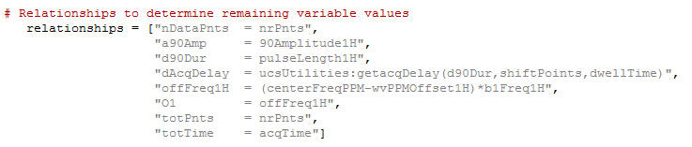

Note that the relationship list is expressed as a list of strings, since these must be stored for later evaluation.

Each entry in the list defines a pulse program variable. Note that it can also define other variables which are used throughout the software. In this case O1 is the offset frequency, totPnts the total number of points collected (which for CPMG experiments may be more than the nrPnts, the number of points collected per echo), and similarly the totTime is the total acquisition time, which might be longer than the individual acquisition time; acqTime (also the case for the CPMG). Please see below for a list of global pulse program parameters and their meanings.

The relationships list also shows an example of a procedure call to update a parameter, in this case the acquisition delay so as to avoid first order phase corrections. This procedure depends on several other parameters such as the pulse length and dwelltime. Note that when calling a procedure from the relationship list, we need to include the file name in addition to the procedure name. i.e:

file_name:procedure_name(arguments)

This is because the relationship list is evaluated in a number of different locations in the software and needs to know where to find the procedure.

If filenames include a hyphen, then you should quote them to prevent this being interpreted as a numerical operation e.g.

"acqShift = \"PGSTE-Li_pp:getAcqShift\"(dwellTime)",

As mentioned above some parameters used here and in other relationships lists are defined or used elsewhere in the Expert code. These include:

acqTime ............ the ideal duration of the data acquisition (dwellTime * nrPnts) in milliseconds.

dwellTime .......... the sampling interval in microseconds.

nrPnts ................ the number of points to collect during the acquire command.

pgo ..................... the pulse gate overhead delay. This is defined in the Spinsolve preferences dialog and defaults to 5 µs. It is the time between the start of an RF pulse command and when the pulse actually appears.

rxLat .................. receiver latency. A time shift required to align the collected data with the ideal start of the sampling interval. (In microseconds).

wvPPMOffsetX … the standard PPM frequency offset for the nucleus X. (e.g. 4.74 for the water peak).

x/y/zshim .......... the shim values found for the linear gradients. These are updated after a shim experiment is performed. These are required when crusher gradients are applied.

Other following parameters can always be defined here and will be used elsewhere:

The following variables should be defined in the user interface list. They are used for converting from Hz to PPM when generating plot axes, for post processing and when exporting data to MNova. Note that some of these may be present in parameter groups and need not be additionally added (e.g. bandwidth and bandwidthPPM).

Nucleus …………..… the name of the nucleus e.g. 1H or 13C. For 2D experiments this should have two parts f2-f1 e.g. 13C-1H.

b1FreqX ……………. The frequencies off all nuclei targeted in the experiment. X is the nucleus e.g. 1H, 13C etc.

centerFreqPPM … the offset in PPM which defines the centre frequency of a 1D spectrum. This value will be added to the appropriate b1Freq value.

centerFreqXPPM . when multiple centre frequencies are defined they should use this format, where X is the nucleus e.g. 1H, 13 C etc.

offFreqX …………… The offset of the transmit frequency in Hz for nucleus X.

bandwidth ……..... The bandwidth of the data acquisition (in kHz) Equal to 1000/dwellTime.

bandwidth2 ….….. The bandwidth of the second dimension in a 2D experiment (in kHz). (Actually f1!)

bandwidthPPM .... the bandwidth in PPM (as an alternative to kHz.

bandwidthXPPM . The bandwidth in the X (f1/f2) dimension (alternative to kHz variables)

The following items should always be included in the relationships list. They define the operating frequencies of the transmit and receive channels as well as the total acquisition duration and size. Older versions of pulse programs used the b1FreqX and O1 parameters for this purpose, but these options should now be avoided as their interpretation is a bit ambiguous when multiple nuclei are targeted.

freqCh1 ....... the transmit frequency of channel 1 – this is the proton and fluorine channel. Units: MHz.

freqCh2 …….. the transmit frequency of channel 2 – this is the X channel. If this is not defined it will default to freqCh1. Units: MHz.

freqRx ……….. the receive frequency. If not defined this will default to freqCh1. Units: MHz. (Note that this value should not be multiplied by 10 as required in some other places).

totTime ……. The total duration of the data collection. Normally equal to acqTime, but some experiments such as CPMG collect data in blocks which will result in longer times (e.g. totTime = acqTime*nrEchoes).

totPnts ……… The total number of data points collected. Normally equal to nrPnts but some experiments such as CPMG collect data in blocks which will result in longer times (e.g. totPnts = nrPnts*nrEchoes).

## Understanding the various frequencies defined in an Expert

There are a number of frequencies define in the previous parameter list and it is important to understand the meaning of these to enable effective design of experiment.

The frequencies b1FreqX defined for each nucleus are calculated during the lock and calibrate experiment in the following way. First the resonant frequency of a significant proton peak is found e.g. the water peak at 4.74 ppm. This is stored in the parameter b1Freq1H (in MHz). From this frequency we determine the frequency at 0 ppm. This becomes b1Freq1HZero. Then for all other supported nuclei we calculate b1FreqX according to the formula:

b1FreqX = b1Freq1HZero * gyroX/gyro1H * (1 + ppmOffsetX/1e6)

Where gyroX is the resonant frequency of nucleus X if gyro1H = 100 MHz. So b1FreqX is the resonant frequency of nucleus X at a particular offset ppmOffsetX. This parameter is globally accessible with the variable wvPPMOffsetX.

In a typical experiment we define the transmit and recieve frequency to be in the centre of the spectrum. In this case we set:

offFreqX = (centerFreqXPPM – wvPPMOffsetX)*b1FreqX

this is the offset of the centre of the spectrum from the reference peak used for calibrating this nucleus in Hertz. From this we can define the transmitter frequency in MHz for channel A in MHz:

freqChA = b1FreqX + offset/1e6

The channel number ‘A’ here can be 1 or 2 and this depends on whether X = 1H/19F (channel 1) or some other nucleus (channel 2). In most cases the receive frequency will be the same:

freqRx = freqChA.

## The group list

It is possible to define all the graphical user elements in the interface list and that is the case with the Proton sequence. However, if you wish to minimise the number of elements in the list you can define a ‘groups’ list. These are predefined groups of controls which will be included with a single name. e.g. the Proton interface is included with the following list (currently commented out):

groups = ["Pulse_sequence","Progress","Acquisition",

"Processing_Std","Display_Std","File_Settings"]

Here the first entry includes those items defined in the interface list. The name for the group list in older versions of Expert was ‘tabs’ and refers to the legacy interface (V3) which grouped controls into tabs. In the case of the newer Expert interface the controls groups are separated by dividers (dv) e.g

"", "Acquisition", "dv", "";

Note that the divider control has no associated variable or data type. It produces the following result in the user interface:

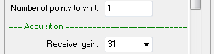

However, an option in the Spinsolve preference (Display group help buttons) allows a help button to be added to the divider.

Pressing the small button on the left side of the divder will print a description of the controls in this group to the command line interface.

Control groups are defined in the following folder:

$appdir$\\Macros\\UCS-PP\\Tabs\\AlternateInterface

For example, the Display_Std interface macro looks like this:

procedure(interface_description)

interface = [

"usePPMScale","Use ppm scale?","cb", "string", "no,yes",

"dispRangeMinPPM","Minimum ppm value","tb", "float", "[-2000,2000]",

"dispRangeMaxPPM","Maximum ppm value","tb", "float", "[-2000,2000]",

"dispRange","Display range (Hz)","tb", "float", "[0,2e6]"]

endproc(interface,"Display")

Note that currently, control group interfaces use 1D lists.

For a description of the supplied group lists please see Appendix B. Of course, you can also add your own groups using the supplied ones as examples.

If you are not going to use groups, then you don’t need to include this list, but be sure to return list(0) in this case as the first argument in the procedures endproc command. (See Proton experiment for an example).

## The variable list

This is a list of the pulse program variables that you wish to modify during the experiment. For example, if you are performing an experiment where the RF pulse amplitude is varied you would include the name of the amplitude variable, e.g. in the Proton experiment this might be a90Amp. In this case you would write:

variables = ["a90Amp"]

If there are no variables to modify then make a single empty element i.e. [""].

## The pulse program

This is the core of this file. These commands describe the pulse program which will be run on the spectrometer. They must be surrounded by the initpp and endpp commands.

# Pulse sequence

initpp(dir) # Initialise the spectrometer

pulse(1,a90Amp,p1,d90Dur) # RF pulse on channel 1 with phase p1 length d90Dur

delay(dAcqDelay) # Pulse - acquire delay

acquire("overwrite",nDataPnts) # Acquire FID

parList = endpp() # Combine events and return ordered parameter list

These commands are rather special – unlike other Prospa commands they don’t execute the action immediately, but as mentioned above, build up the pulse sequence event table which will be executed later by the spectrometer. The endpp completes the event table assembly and returns a list of variable names in the order they appear in the pulse sequence. In this case

parList = ["a90Amp", "p1", "d90Dur", "dAcqDelay", "nDataPnts"]

Note that inside the pulse program macro, unquoted strings are treated as quoted strings (as they are in the command line interface). This keeps the pulse sequence description cleaner and easier to read. To prevent an external global variable from accidentally replacing an unquoted pulse sequence argument, global and window variables are not accessible from within this macro.

## The phase cycle matrix

Phase cycling is performed by replacing the parameters p1, p2 ... with the phases stored in the phaseList 2D matrix before each scan. Each row of the matrix corresponds to a different phase variable, while the last row is the acquisition phase. Each column is applied in a different scan. Column 1 for the first scan, column 2 for the second and then wrapping around to the start when we run out of columns. The numbers in the matrix represent multiples of 90 degrees. Fractional numbers can be used for smaller increments. (e.g. 0.5 == 45 degrees)

So, in the Proton example,

phaseList = [0,1,2,3; # p1 : Pulse phase

0,1,2,3] # pA : Acquire phase

the phase of the RF pulse steps from 0 to 90 to 180 to 270 as the scans are incremented. The acquisition phase is stepped in the same way.

If phase cycling is disabled in the user interface using the ‘Phase cycle’ check-box then the phases in the first column will be used in all scans.

## The returned variables

The various lists generated in the pulse program need to be returned to the compiler. This is done with a comma delimited list of parameters in the endproc command.

endproc(parList,group,interface,relationships,variables,dim,phaseList)

In addition to the lists we have just discussed, there is also a **dim** variable which is used in the legacy interface (V3). This should be replaced by zero if it is not used, however it must still be included for backward compatibility.

If the group list is not used then you can replace this variable with a null list i.e. list(0). So, for example, in the Proton pulse sequence file, if the group list is not used, the return parameters would look like this

endproc(parList,list(0),interface,relationships,variables,0,phaseList)

## How parameters are initialised in the user interface

It is worth considering how the user interface parameters are chosen when selecting an experiment from the main menu.

Once the parameter interface list has been created it is populated with the default parameter list – the file for this is displayed in the *Default Parameters* tab.

Next the program will look for a procedure called *getFactoryBasedParameters* in the Pulse program or the Experiment control file. If it exists, then this procedure will be executed. Typically, this procedure will contain a command to access the factory parameter settings from the spectrometer (these are manually accessible using the ‘Open Spinsolve parameter dialog’ option in the main File menu.) This command looks like this in the proton experiment:

specPar = gData->getXChannelParameters("1H")

gData is the globally accessible data class used by SpinsolveExpert. The argument to the procedure *getXChannelParameters* should be the nucleus of interest. This is important since some spectrometers support multiple nuclei and the parameters returned may depend on that selection.

specPar is then a structure returned with these parameters. You can add a print statement to see the contents of this structure. Once loaded this structure is made into local variables with the assignlist command and then a new parameter list is formed using these values e.g.

par = ["rxGain = $modelPar->rxGain$",

"pulseLength1H = $PulseLength_1H$",

"90Amplitude1H = $PowerLevel_1H$",

"b1Freq1H = $Frequency_1H$"]

PulseLength_1H, PowerLevel_1H and Frequency_1H are all spectrometer parameters, previously stored in specPar. (See 5.3Appendix I for a list of these variables). These are values which have been calibrated for your spectrometer in the factory. The rxGain parameter will depend on the spectrometer frequency, but this is more generic and is stored in the modelPar structure which is returned from *ucsUtilities:getModelBasedParameters* procedure called before the above lines.

Note that procedures or variables in classes are accessed using the arrow (->) notation while procedures in macros are access using the colon (:) notation.

The parameter list *par* is then returned to the calling program and is used to update those parameters listed on the left of this list.

If the procedure *getFactoryBasedParameter* is not present, then those values stored in the default parameter file will be used instead (and these will usually be inappropriate for your spectrometer.)

The final step is to replace the frequencies *b1FreqX* with the values found or calculated during the last lock and calibrate step. These are called *common* parameters.

Note that you can always manually change these updated parameters before the experiment starts (except for the common parameters which are read only).

# Writing a new pulse program

With this brief overview of the Proton sequence and how parameters are initialised, we can move on to looking how a new pulse program might be written. Because of the number and complexity of the files involved, it doesn’t make sense to write an experiment from scratch. Rather you should take an existing experiment and modify it.

Start by opening an experiment which is similar to the one you want to write. For example, let’s write a pulse duration-sweep experiment to determine the correct 90-degree pulse length. Since the core experiment here is a simple Pulse and Collect, first open Proton in the pulse sequence editor and compiler window. Then in the file menu, select the option “New pulse program from existing file”. Select Proton from the dialog window which appears and enter the name for the new experiment – in this case ProtonDurationSweep2:

Note that experiment names should be unique as Expert will simply run the first one it finds with this name. Since ProtonDurationSweep already exists in the Proton menu we have added a ‘2’ at the end.

Press OK. This will make a copy of all the Proton files, but with the new name substituted. If you compile this experiment (press the compile button) it will produce identical results to the Proton experiment. The new experiment will now also be visible in the Proton (1H) menu. It is recommended that you choose a different path for your own experiments to prevent accidental deletion when updating the software. In this case you will need to add that path to the main menu to access the experiment. This can be done by dragging and dropping the *parent* folder of the experiment onto the Expert main menu or by adding it using the ‘Experiments Menus’ option in the SpinsolveExpert preferences dialog found in the Files menu. Note that you must drag and drop the *parent* directory of ProtonDurationSweep2 onto the menu bar not the ProtonDurationSweep2 directory itself otherwise you won’t be able to access the experiment.

With the experiment loaded into the user interface it can now be modified. Since we want to change the pulse duration, we need to expose the pulse length in the pulse program. To do this, modify the variable list to include the pulse length:

variables = ["d90Dur"]

Save the pulse program (Ctrl+S) and recompile (Press the Compile button or Ctrl+Shift+C)

Before we modify the Experiment Control Macro to sweep the pulse duration let’s have a look at the structure of this file.

# The Experiment Control Macro

This macro contains several procedures:

The entry procedure (the actual name will be the same as the experiment) ... this provides the option to add the experiment to the user interface or if the shift key is pressed, to edit the experiment. In addition to selecting the experiment from the menu it is also possible to load an experiment into the user interface by typing the name of this procedure at the command line in the form of a procedure call e.g. Proton().

backdoor ... this allows the experiment to be run without using the legacy V3 user interface. Instead, a list of parameters is passed. This is used by all Expert experiments.

getseqpar ... get the sequence parameters. This returns the important parameters from the pulse program macro, which were collected and stored in this procedure when the pulse program was compiled. This includes the relationships list, the variables list, the list of pulse program parameters, the pulse program name, and the phase cycling list.

execpp ... executes the pulse program. This contains the commands to send the event table with all relevant parameters to the spectrometer. It instructs the spectrometer to be execute the event table and then waits for it to finish. It then reads the collected data, processing and displaying it. This process is then repeated for the desired number of scans, phase cycling the RF pulses and accumulating the collected data as specified in the phase list. When the specified number of scans has completed the data are saved to the folder specified by the Experiment base-path, date and time hierarchy and file comment. As a final step the experimental data is packed into a structure and returned to the calling program. This information is typically only used by some scripts.

getPlotInfo ... specifies the file names associated with the various plots in the user interface. This is used for saving the data in each plot and also for reloading the last data set when the experiment is reselected from the history list.

expectedDuration ... this returns the expected duration of the experiment in seconds. This needs to be calculated, which is usually a simple task if a repetition time is specified – more complicated if an interexperiment time is used. (See 5.3Appendix H).

saveProcPar ... saves the processing parameters when the experiment is complete. This is useful if one wants to reprocess the raw FID data in the same way at a later date.

Once an experiment has been selected from one of the experiment menus and the Run button is pressed, the following actions will occur *before* the execpp procedure is called.

1. A check is made to see if the system is locked and if the temperature is within acceptable limits. This does not prevent the experiment from running, but updates the Status indicators.
2. The user interface is modified for Run mode. This means the required plots are displayed and various controls are disabled to prevent unwanted user interactions while the experiment is running.
3. A separate thread is run to control the progress bar based on the value returned by the expectedDuration procedure in the Experiment Control macro.
4. Another thread is started to execute the experiment. Runing the progress bar update and experiment in separate thread allows the user interface view to be modified and windows resized during the experiment as well as giving a smoother update to the progress bar.
5. In the experiment thread the experimental parameters are read from the user interface and merged with spectrometer and common parameters. All user interface parameters are checked for invalid values.
6. The backdoor procedure is then called. This calls an initialisation procedure (initAndRunPP). Here the experiment data folder is created and an acquisition parameter file acqu.par is written based on the chosen experimental parameters.
7. The user-defined experimental and pulse sequence parameters are then combined with fixed spectrometer parameters and system preferences to produce the required low level list of pulse sequence parameters which will be passed to the spectrometer processor. For example, this involves converting RF amplitudes from dB to the 14-bit digital value required by the spectrometer’s digital synthesiser.
8. The pulse program’s event table in binary form is sent to the spectrometer via USB.
9. The execpp procedure in the Experiment Control macro is the run with the pulse sequence parameter list as an argument (ppList) along with other lists.

The execpp procedure then performs the following functions:

1. It sends the experiment parameters to the spectrometer (which may change from scan to scan).
2. It executes the pulse program, collecting and scaling the data.
3. The data is then processed, displayed and saved.

Following the execution of execpp the interface is enabled and restored to normal operating mode (which allows menu activation and all plot interactions).

We will now look at the function of execpp in more detail.

## The execpp (execute pulse program) procedure arguments

If the pulse sequence code in the Pulse Sequence macro defines the experiment, then the execpp procedure in the Experiment Control macro controls it. Let’s looks at the Proton experiment macro.

First note that you can jump to different procedures in a macro by using the Procedures menu in the Pulse program editor and compiler window (or any Prospa editor).

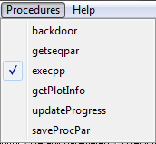

The first line of the procedure lists the passed arguments:

procedure(execpp,guipar,ppList,pcList,pcIndex,varIndex)

execpp is the procedure name, guipar is the list consisting of all the parameters defined in the Proton parameter list plus all the parameters in the relationships list defined in the pulse program macro. Here are some of them:

guipar = {

90Amplitude1H = 0

a90Amp = 90Amplitude1H

accumulate = "yes"

acqTime = 3276.8

b1Freq1H = 61.9303168d

bandwidth = 5

d90Dur = pulseLength1H

...

yshim = -721.995

zf = 1

zshim = -1753.47

}

It also includes a number of global variables such as receiver calibrations and gyromagnetic ratios for the various nuclei, x,y, and z shim values as well as other information which may be needed in the macro.

You can list these (or other parameters) yourself by adding the line

pr sortlist(guipar)

to the execpp code. To see all locally define variables add the line

pr local

On the FX3 based spectrometer the parameter ppList is not used an may be ignored, however it should be passed to the various procedures in execpp to allow the experiment to function on a DSP based spectrometer as well.

pcList is the phase cycle list, but now scaled to be in hardware relevant units (90 degrees == 16384)

pcList =

0 16384 32768 49152

0 16384 32768 49152

pcIndex is not used by FX3 spectrometers.

varIndex is the position of the variables to modified in the pp_list parameter defined in the getseqpar procedure. This is not used in the Proton experiment.

## The execpp procedure in detail

Now we can break down the various parts of the execpp procedure. The first step is to extract all the guipar list parameters and make them local variables. This is done with the assignlist command:

# Make all gui parameters available

assignlist(guipar)

Next, we allocate space for the collected data. totPnts is the number of complex points in the FID which, in this case, is also the same as nrPnts,

# Allocate space for output data

sumData = cmatrix(totPnts)

We then determine the axes for the time (FID) and frequency (Spectral) plots

# Calculate suitable time and frequency axes

tAxis = ([0:1:totPnts-1]/totPnts)*totTime*1000 # ms

fAxis = [-totPnts*zf/2:totPnts*zf/2-1]/(totTime*zf)*1000 # Hz

In addition to totPnts this also uses totTime (== acqTime) and the zero-fill parameter zf, defined in the user interface. This last parameter was part of the guipar list.

If the user wants to apply a time domain apodization to improve SNR we extract this from the filters macro

# Time domain filter

if(filter == "yes")

flt = filters:get_filter(filterType,"FTFid",tAxis/1e6)

else

flt = matrix(totPnts)+1

endif

If not, then the filter is just a constant vector equal to 1.

Next, we indicate that we want 2 plot regions, one for the FID and one for the Spectrum. This function returns plot objects we can use for performing the plot.

# Get plot regions

(prt,prf) = ucsPlot:getPlotReferences()

Note that these plot regions have been defined in the User Interface macro, procedure plot_run_layout and were initialised when the experiment was selected from the menu.

To simplify the generation of axes labels and scales which depend on the ppm/Hz setting and frequency offsets, we call a procedure in the ucsPlot macro to calculate this for us.

# Work out frequency axis scale, label and range

(fAxisDisp,fAxisLabel,fRange) = ucsPlot:generate1DFrequencyAxis(prf, fAxis, guipar)

The core elements of a simple pulse and collect experiment are shown below. First we have the Scan loop:

# Accumulate scans

for(scan = 0 to nrScans-1)

The next command combines several steps – it checks the timing, sends the pulse program event table to the spectrometer, executes the event table and returns the data. Be aware that some of the comments and parameters refer to the DSP mode of operation which is rather different.

# Check timing, update the parameters, run the sequence and return the data

(data,pAcq,status) = ucsRun:runSequence(guipar,ppList,pcList,pcIndex,scan)

The collected data is accumulated, with the acquisition phase cycle being applied.

# Accumlate the data

sumData = ucsRun:accumulate(accumulate,pAcq,sumData,data)

The accumulated data is zero filled and then Fourier transformed:

# Process data

(phasedTimeData,spectrum,ph0) = ucsRun:transformData(zerofill(datacorr.*flt,zf*totPnts,"end"),fAxis,guipar,"fid")

And finally plotted

# Plot the data

ucsPlot:graphTimeAndFreq(prt,prf,tAxis,datacorr,fAxisDisp,spectrum,scan,guipar, "Time data","Spectral data", "Time (ms)","Amplitude (\G(m)V)", fAxisLabel,"Amplitude")

And then we check to see if the Complete button has been pressed during the experiment

# Check if complete button pressed

if(status == "finish")

scan = scan+1

exitfor()

endif

next(scan)

See the experiment ProtonLPShowDetails to see an expansion of the runSequence procedure.

The Proton experiment also includes some commands to minimise first order phase shifts by setting the acquisition delay carefully and modifying the first few data points to account for the digital filters. These are not essential for operation and so for simplicity will not be discussed here.

The next step is to save the data

# Save the data

ucsFiles:savePlot(prt,:getPlotInfo("pt1"),guipar,"noReport")

ucsFiles:savePlot(prf,:getPlotInfo("pt2"),guipar,"simpleReport")

ucsFiles:saveMNovaData(prt,"",guipar,"simpleReport")

This saves the FID and spectral plots in a proprietary Prospa format so we can reload the data later, and also in a more basic format ‘data.1d’ for use with the 3rd party application Mnova. Note the references to the local procedure getPlotInfo which returns the filenames for the FID and spectral files.

Finally, the processing parameters used are saved for future reference in a proc.par file

# Save the processing parameters

:saveProcPar(guipar,ph0,fRange)

and then the data is packed up into a structure and returned to the calling procedure. Note the structure naming here – this should be used for all 1D data sets. For 2D change result->tAxis to result->tAxes and result->fAxis to result->fAxes.

# Pack the data into a structure

result = struct()

result->tAxis = tAxis

result->tData = sumData/scan

result->fAxis = fAxisDisp

result->fData = spectrum/scan

result->par = struct(guipar)

result->p0 = ph0

# Return result

return(result)

## Modifying the execpp procedure to vary the pulse duration

Now we have covered the basic pulse and collect experiment we will consider how to incorporate changing the pulse length parameter as discussed earlier in *Writing a new pulse program*. There we included a non-empty variable parameter list in the pulse sequence file:

variables = ["d90Dur"]

In the execpp macro this will appear in the varIndex argument as an array with the single value 2

varIndex = [2]

This refers to parameter 2 in the parameter list pp_list returned by the pulse program macro and saved in the getseqpar procedure. (Note that the index is zero based).

pp_list = ["a90Amp","p1","d90Dur","dAcqDelay","nDataPnts"]

To use this parameter, we add an extra for-loop outside the scan loop. We also add extra 2D storage for each spectrum recorded:

# Calculate the pulse length matrix

minLength = pulseLength1H

maxLength = minLength+nrLengthSteps*stepNr

pulseLengths = linspace(minLength, maxLength, nrLengthSteps)

# Storage for the fids and spectra

fid2d = cmatrix(totPnts, nrLengthSteps)

spectra = cmatrix(totPnts*zf, nrLengthSteps)

# Vary the pulse duration

for(stepNr = 0 to nrLengthSteps-1)

# Allocate space for output data

sumData = cmatrix(totPnts)

# Accumulate scans

for(scan = 0 to nrScans-1)

Note that since we have introduced three new user variables; minLength, lengthStep and nrLengthSteps we need them to the pulse sequence user interface as well:

"minPulseLength", "Min. pulse length (µs)", "tb", "pulselength";

"lengthStep", "Pulse step size (µs)", "tb", "pulselength";

"nrLengthSteps", "Nr. of length steps", "tb", "integer,[1,100]";

Don’t forget to recompile after making changes to the *_pp.mac file.

The next step is to save each collected spectrum into the 2D spectra matrix. This is done between the end of the scan loop and the end of the pulse length loop.

next(scan)

# Save the FID and Spectrum

fid2d[~,stepNr] = sumData

spectra[~,stepNr] = spectrum

next(stepNr)

The tilda symbol (~) means replace a row. A colon (as in Matlab) can also be used. Note that the 2D matrix index order in Prospa is column, row (x,y) not row, column as it is in other languages. (We considered the x,y order for 2D matrix indexing or the x,y,z order for 3D matrix indexing more logical than y,x, or y,x,z).

We also save the fids to allow export to MNova for reprocessing there.

To give some feedback to the user we can plot the accumulated spectra into an additional plot. To do this we need to add the extra plot pt3 in the User Interface macro:

procedure(plot_run_layout)

layout = ["pt1", "pt2"; "pt3"]

endproc(layout)

procedure(plot_load_layout)

layout = ["pt3"]

endproc(layout)

These define the layout of plots when running and reloading experiments.

We also need to add a reference to this third plot in the execpp procedure by changing the number of plots from 2 to 3 and returning another plot name prs:

(prt,prf,prs) = ucsPlot:getPlotReferences()

We can then display the collected data as it is acquired:

next(scan)

# Save the FID and Spectrum

fid2d[~,stepNr] = sumData

spectra[~,stepNr] = spectrum

StackedPlot(prs, real(spectra), stepNr, fRange, fAxisDisp, "yes", pulseLengths,"linear", "Frequency (ppm)", "Pulse length (\G(m)s)","Spectra for different pulse lengths")

next(stepNr)

The StackedPlot procedure combines a number of 1D FIDs together in a single plot offsetting each one based on the step number. You can enter this procedure to see its function using the Ctrl+Double click shortcut.

If the pulse sequence is now recompiled and a sensible pulse length range added (2 to 21 µs in 1 µs steps), we gain the following result

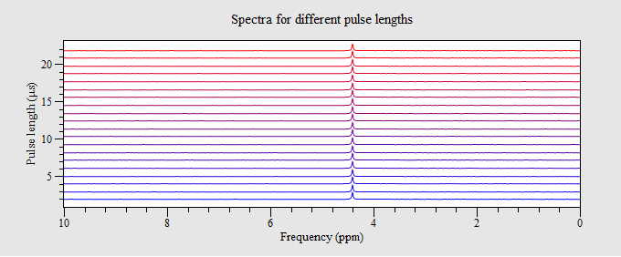

The first thing we notice is that the amplitude of each spectrum is not changing. That is because we have not changed the pulse length being sent to the Spectrometer. To do this we need to modify the parameter before it is sent to the spectrometer. We do this with the utility procedure ucsRun:setPPDelay:

# Vary the pulse duration scans

for(stepNr = 0 to nrLengthSteps-1)

# Modify ppList with the new pulse length

ppList = ucsRun:setPPDelay(ppList,varIndex[0],pulseLengths[stepNr])

# Allocate space for output data

sumData = cmatrix(totPnts)

# Accumulate scans

for(scan = 0 to nrScans-1)

If you look in the macro ucsRun you will find a number of other conversion procedures which you need for updating different parameters. (See appendix C for a list of these).

After this change we see the amplitude changing nicely

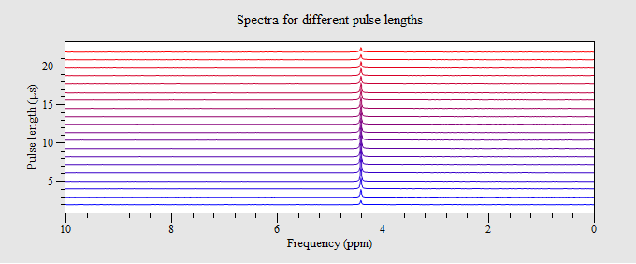

Just one more step is necessary – we need to save this data. Modify the save commands to save the stacked plot and the raw FID data for MNova analysis:

ucsFiles:savePlot(prs,:getPlotInfo("pt3"),guipar,"noReport")

ucsFiles:saveMNovaData(fid2d,"",guipar,"simpleReport")

and in the getPlotInfo procedure make sure to give this new plot a file-name:

info = ["pt3","pulseDurationSweep.pt1"]

We can also add some post processing tools to the user interface macro to change the stacked plot view , integrate the data and give access to MNova.

procedure(processing_controls)

layout = ["buttonLabel = \"View\"", "plotName = \"pt3\"", "macroToRun = \"StackedPlotSetup()\"";

"buttonLabel = \"Integ.\"", "plotName = \"pt3\"", "macroToRun = \"IntegrateRegions()\"";

"buttonLabel = \"MNova\"", "plotName = \"pt3\"", "macroToRun = \"exportMNova2D(\\\"pt3\\\")\""]

endproc(layout)

The View option allows more informative stacked plot displays:

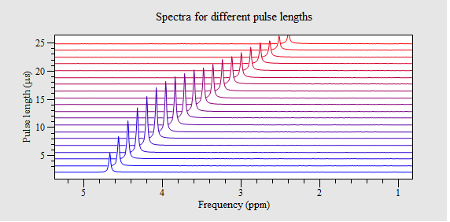

While the Integ option allows analysis of the peak integrals:

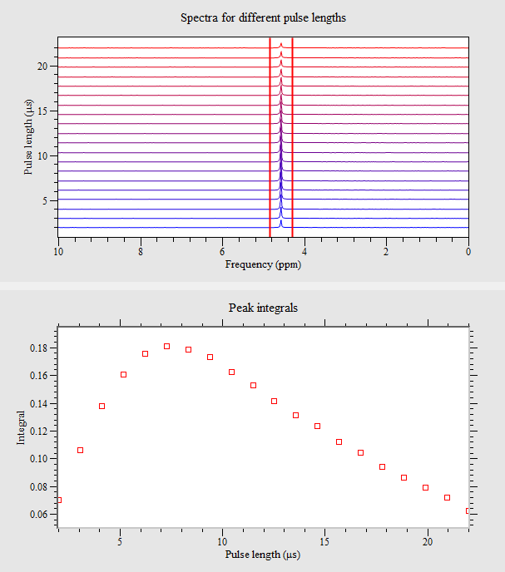



An important step after writing and testing a new pulse program is to manually update the default parameter file or alternatively save the last run set of parameters to the default parameter file. This option can be found in the main Files menu if this has been enabled in the General page of the preferences (*Allow to overwrite defaults parameter files*). This allows subsequent use of the experiment to have sensible start values. It may require some editing afterwards to remove spectrometer specific or unnecessary entries. Be careful not to apply this option to the standard experiments!

To give more useful feedback as to the progress of the running experiment the progress bar should be updated correctly. This requires the addition of the expectedDuration procedure:

procedure(expectedDuration, guipar)

assignstruct(guipar)

totScans = nrLengthSteps*nrScans + useStartDelay

duration = totScans*repTime/1000

endproc(duration)

This just calculates the expected number of scans. useStartDelay is a variable equal to 1 or 0 which controls the addition off a predelay before the experiment starts. This defaults to 0 when in the history mode and 1 when in batch mode.

If you are using an inter-experiment delay rather than the repetition time then this procedure becomes more complicated. In this case you need to calculate the duration of the experiment and then add the inter-experiment delay. This can be more difficult if the experiment duration is varied as in a T1 experiment. In this case you can call the function GetPulseProgramDuration with the name of the protocol to return the duration for the parameters defined in the relationships table. Then you can add the extra times.

psTime = GetPulseProgramDuration("T1iet",1, guipar)*1000

See the experiment T1ie for an example of this.

A completed ProtonDurationSweep experiment is included in the Proton experiment folder for reference. (This version has been modified to allow interactive integration).

Pulse program commands

Here is a list and a short description of all pulse program commands grouped according to the function type. More details can be found by typing help and then the command name in the command line interface e.g.

> help pulse

Acquire NMR data

Blocking acquire

This command acquires data from the Proton or X-channel receiver and stores it in the spectrometer memory. No other command can be run during this process.

acquire( mode, points, [duration])

mode ... is one of:

overwrite .......... data is written to the beginning of memory.

append .............. data is appended to last data collected.

sum ................. the acquired data is summed with the previous data. Can also be called *stack*.

integrate .......... the acquired data is integrated and returned as single point then appended to previously collected data.

integrateandscale . the acquired data is integrated after being scaled by a power of 2 to prevent overflow, then returned as a single point to be appended to the previously collected data.

points .......... the number of complex points collected (maximum approx. 170k). (nx) For sum mode this is limited to 4 k complex points.

duration ........ is an optional short delay, (dx), (1 s to 327 ms), which is applied to the append, sum and integrate modes. This is the total length of time between the start of data acquisition and the next pulse sequence command.

Non-blocking acquire

This command acquires data from the Proton or X-channel receiver in the background, storing it on the transceiver board. It returns immediately so other commands can be run.

acquireon(points)

This is equivalent to the mode = overwrite. i.e. start acquiring and store at start of memory.

or

acquireon(mode, points)

mode ... is one of:

overwrite ... data is written to the beginning of memory.

append ....... data is appended to last data collected.

adc .......... acquire data at maximum sample rate (100 MSPS) from the ADC without applying a digital filter and write from the beginning of memory. Note total acquisition time will be memory limited since DW = 0.01 s)

points: the number of complex points collected (maximum 170k). (nx)

This command reads in the acquired data obtained with acquireon according to the mode setting, copying it to the DSP board memory.

acquireoff( mode, points)

mode ... is one of:

overwrite ... stop acquiring.

adc ......... stop acquiring.

pause ....... pause acquisition. (See HSQC-HMBC expt for example)

finish ....... stop acquiring.

points ... the number of complex points to collect. (nx)

Note that the mode parameter is ignored on the fx3 and these parameters are really for the DSP models, however they help explain what the acquireoff is doing and should be included for DSP compatibility.

For more details on acquisition timing see Appendix D – acquisition explained.

Clear the spectrometer data memory

If the acquire command uses the sum mode (i.e. adding to existing memory) this command ensures the memory is first zeroed. On FX3 spectrometers an additional parameter is required and that is the number of summations that are expected.

cleardata(number_of_points, number_of_summations)

number_of_points ...... the number of points in data memory to clear (nx)

number_of_summations .. the number of times the acquire command will be called (nx)

Delay for a specified time

Short delay

delay(duration)

duration ....... is a short delay, (dx), (0.25 s to 42 s)

Note that for compatibility with the DSP based spectrometers we use the wait command for delays greater than 327 ms.

Long delay

This delay provides a much larger range of values at the expense of more code in the pulse program. The largest delay is for all practical purposes unlimited.

wait(duration)

duration ....... is a long delay, (wx), (> 2 s)

Frequency modifications

Set the receiver frequency

setrxfreq(value)

value ..... frequency to use (MHz) (fx).

Note that the receive frequency supplied as an argument should be multiplied by 10.

Set the transmitter frequency

settxfreq(value)

value ..... frequency to use for channel 1 (MHz) (fx).

or

settxfreq(channel, value)

channel ... which channel frequency to change (1/2).

value ..... frequency to use (MHz) (fx).

or

settxfreqs(value1, value2)

value1 ... frequency to use for channel 1 (MHz) (fx).

value2 ... frequency to use for channel 2 (MHz) (fx).

Increment the receiver frequency

incrxfreq(increment)

increment ... amount frequency should be incremented by (MHz) (fx).

Note: currently not available on FX3 spectrometers

Increment the transmitter frequency

inctxfreq(increment)

increment ... amount frequency should be incremented by (MHz)  (fx).

Note: currently not available on FX3 spectrometers

Looping

Start a loop

All commands between loop and matching endloop will be repeated loop_number times. loop_number >= 0.

loop(loop_name, loop_number, [duration])

loop_name ........... unique identifier for the loop (lx)

loop_number ......... number of times to execute the loop (nx)

duration ............ by default, ,the duration is 1 s, however you can reduce this down to 0.1 us if necessary.

End a loop

endloop(loop_name, [duration])

loop_name ........... unique identifier for the loop (lx)

duration ............ by default, the duration is 1 s, however you can reduce this down to 0.1 us if necessary.

Note that loops can be nested.

Make sure the loopnames are unique (lxxx), otherwise an error will occur on compilation.

Conditional statements

Execute a block of code is a statement is true. The block is bounded by the iftrue and endiftrue commands.

iftrue(block_name, test_value)

block_name ........... unique identifier for the block (sx)

test_value ........... the value to be tested for non-zero (nx)

endiftrue(block_name)

block_name ........... unique identifier for the block (sx)

Note this command was originally called skiponzero or skiponfalse and these variants are still available if the logic makes more sense. This is why the block_name starts with an ‘s’.

RF pulse production

Several commands can be used to produce an RF output, either as a pulse or a phase, frequency and amplitude modulated waveform.

Simple pulse

Generates a single or dual pulse with specified amplitude, phase, duration and optional frequency.

*Single channel version*

pulse(destination, amplitude, phase, duration, [frequency])

destination .... is either 1 (proton channel) or 2 (X channel)

amplitude ...... the pulse amplitude, (ax).

phase .......... pulse phase, (px),  – set in the phase cycle array.

duration ....... is a short delay, (dx), (1 s to 327 ms).

frequency ...... an optional frequency in MHz (fx).

*Dual -channel version*

pulse( 1, amplitude1, phase1, frequency1,

2, amplitude2, phase2, frequency2, duration)

Parameters as above, except channels are fixed, frequencies are required, and the duration is common.

Shaped pulse

Generates RF pulses with modulated amplitude on one channel.

shapedrf1(destination, ampTable, phase, tableSize, stepTime)

destination .... is either 1 (proton channel) or 2 (X channel)

ampTable ....... amplitude tables (magnitude only), (tx).

phase .......... phase offset for channel, (px),  – set in the phase cycle array.

tableSize ...... the number of entries in each table, (nx).

stepTime ....... how long each step will last (s) (dx).

Generates RF pulses with modulated amplitude *and* phase on one channel.

shapedrf2(destination, ampPhaseTable, phase, tableSize, stepTime)

destination .... is either 1 (proton channel) or 2 (X channel)

ampPhaseTable . an interleaved amplitude and phase table (tx).

phase .......... pulse phase, (px),  – set in the phase cycle array.

tableSize ...... the number of entries in each table, (nx).

stepTime ....... how long each step will last, (dx).

Generates RF pulses with modulated amplitude on both channels.

dualshapedrf1(ampTable, phase1, phase2, tableSize, stepTime)

ampTable ........ 2 channel interleaved amplitude tables (tx).

phase1 .......... phase offset for channel 1, (px),  – set in the phase cycle array.

phase2 .......... phase offset for channel 1, (px),  – set in the phase cycle array.

tableSize ...... the number of entries in each table, (nx).

stepTime ....... how long each step will last, (dx).

Generates RF pulses with modulated amplitude and phase on both channels.

dualshapedrf2(ampPhaseTable, phase1, phase2, tableSize, stepTime)

ampPhaseTable . 2 channel interleaved amplitude and phase tables (tx).

phase1 .......... phase offset for channel 1, (px),  – set in the phase cycle array.

phase2 .......... phase offset for channel 1, (px),  – set in the phase cycle array.

tableSize ...... the number of entries in each table, (nx).

stepTime ....... how long each step will last, (dx).

For more information on using interleaved table see Appendix E using tables.

Chirped Pulse

Generates an RF pulse with modulated amplitude and frequency on a single channel

chirprf2(destination, ampTable, freqTable, phase, tableSize,

stepTime)

destination ..... is either 1 (proton channel) or 2 (X channel)

ampTable ........ an amplitude table (magnitude only), (tx).

freqTable ....... a frequency table (positive only), (fx).

phase ............ pulse phase, (px),  – set in the phase cycle array.

tableSize ....... the number of entries in each table, (nx).

stepTime ........ how long each step will last, (dx).

Switch on the RF output

Simply switches on the RF output. Use delays to define the pulse duration

txon(destination, amplitude, phase)

destination ..... is one of: 1/2/1nb/2nb/w1/w2

amplitude ....... the pulse amplitude, (ax).

phase ............ pulse phase, (px),  – set in the phase cycle array.

The destination field options are:

1 … Channel 1 (1H/3H/19F)

2 … Channel 2 (other nuclei)

1nb … Channel 1 but RF amplifier is not activated (no blanking pulse)

2nb … Channel 2 but RF amplifier is not activated (no blanking pulse)

w1 …. Channel 1 with wobble mode activated

w2 …. Channel 2 with wobble mode activated

Switch off the RF output

Switches off the RF output.

txoff(destination)

destination: is one of: 1/2/1nb/2nb/w1/w2

Shim and gradient commands

These commands control the currents in the various shims and where fitted, the single gradient channel.

Shim control

Set a shim value

shim16(channel, amplitude)

channel ..... the shim channel (1-15) (nx)

amplitude ... the shim value (16 bit signed number) (nx/tx)

Ramp a shim current linearly

shimramp16(channel, start, end, steps, duration)

channel .... the shim channel (1-15) (nx)

start ...... the start ramp value (16 bit signed number) (nx/tx)

end ........ the end ramp value (16 bit signed number) (nx/tx)

steps ...... number of steps in the ramp (nx)

duration ... how long each step lasts (dx)

Gradient control

Switch on the gradient (where fitted)

gradon(amplitude)

amplitude ... the gradient value (a 16 bit signed number) (nx/tx)

Switch off the gradient (where fitted)

gradoff()

Ramp the gradient current linearly

gradramp(start, end, steps, duration)

start ...... the start ramp value (16 bit signed number) (nx/tx)

end ........ the end ramp value (16 bit signed number) (nx/tx)

steps ...... number of steps in the ramp (nx)

duration ... how long each step lasts (dx)

Table commands

These commands control the location of the table index – i.e. which value in a table will be used next.

decindex(table, [decrement])

table ........ table index to decrement (tx)

decrement .... amount to decrement by (defaults to 1) (nx)

incindex(table, [increment])

table ........ table index to increment (tx)

decrement .... amount to increment by (defaults to 1) (nx)

setindex(table, index)

table ... table index to increment (tx)

index ... value for the index (nx)

See Appendix xx for more details on using tables.

Available control groups

Following is a list of the control (tab) groups available which are used by some of the experiments, and the key feature(s) which differentiate them. These may be found in the folder:

<prospa>\Macros\UCS-PP\Tabs\AlternateInterface

Acquisition

Used when collecting data by specifying a dwelltime (sampling time) and the number of points to collect. These are the natural machine units, although not necessarily the most comfortable for the spectroscopist. However, note that the corresponding bandwidth and acquisition time are reported bottom of this group and are automatically updated if the number of points or dwell time is modified.

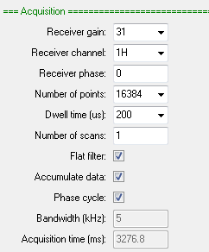

AcquisitionBW

Used when collecting data by specifying a bandwidth in PPM and an acquisition time. Be aware than small bandwidths (or large dwell-times) may lead to excessive first order phase distortions.

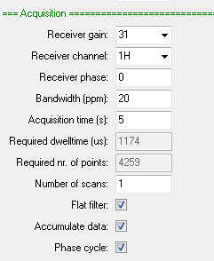

Note that the dwelltime and required number of points are automatically updated if the bandwidth or acquisition time is modified. Because of the number of points is unlikely to be a power of 2 zero filling will be required before processing is applied.

AcquisitionBW2D

A 2D version of AcquisitionBW.

AcquisitionFIR

The same as the standard acquisition list except it provides the option to specify how much FIR decimation should be applied. This is used with sequences which do not apply the FIR filter in the spectrometer hardware but rather delay this until the data is in the PC. This allows linear prediction to be used to minimise baseline and first order phase correction problems by predicting the first few data points in the FID. However, it does require that more data is collected. This is determined by the FIR decimation factor. This option is unused in the current version of Expert.

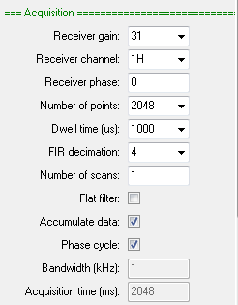

Display_Std

Allows the selection of a ppm or Hz scale. The former allows both scale limits to be selected while the latter just allows a width. Zero in the display range (Hz) field displays all the data if ‘Use ppm scale’ is not checked.

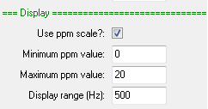

Display_2D

The 2D version of Display_Std which provides control of the 2nd dimension range.

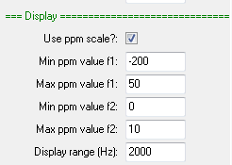

Display_Hz

Simply allows the display range to be selected in Hz.



File_Settings

This option allow selection of whether the collected data should be saved or not.

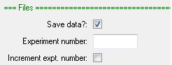

Jres_processing

The same as Processing_std except there is an option to tilt the 2D data by 45 degrees and an option to disable 2D processing and display until the experiment is finished

Processing_std

Provides options to zero fill and apodize the time domain data. Different frequency domain phasing options are also provided.

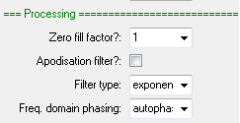

Processing2d_std

The same as Processing_std except there is an option to disable 2D processing and display until the experiment is finished (useful for large data sets as this may allow shorter repetition times.)

Processing_autophase

Just provides an autophase option. Useful with the CPMGInt where time domain filtering is not an option.



Processing_filter_autophase

The same as Processing_std except it includes an autophase option as well. Useful when you are wanting to phase a group of FIDs based on a reference FID (e.g. a T1 or a T2 experiment).

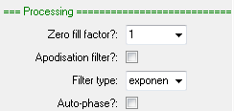

ProcessingBW

Use this option in combination with AcquireBW to work with acquisition time and bandwidth rather than dwellTime and nrPnts. In this case you define the number of spectral points to be equal to or greater than the number of time domain points collected (which won’t necessarily be a factor of 2 which is necessary for the Fourier transform used).

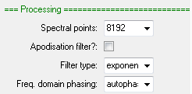

Procedures to change pulse program values

Many pulse program values are presented in a form which is not suitable for the hardware (dB for RF amplitude, frequencies in MHz, delays in microseconds etc.). This conversion is done automatically for most parameters before reaching the execpp procedure. However when modifying a parameter between scans you will need to explicitly convert the user unit into machine units and update the event table. Procedures written in the macro ucsRun can be used for this purpose.

All have the same format:

pulse_parameter_list = procedure_name(pulse_parameter_list,

index_of_parameter,

user_unit)

In execpp the pulse_parameter_list is the variable ppList. The parameter index is stored in the array varIndex and user_unit you must supply.

Here is the list of helper procedures in ucsRun:

setPPAmplitude ...... set an RF amplitude (dB) in the event table

setPPDelay .............. set a short delay (µs) in the event table

setPPLongDelay ...... set a long delay (µs) in the event table

setPPNumber ......... set a number in the event table

setPPPhase ............. set an RF phase (0-4) in the event table

setPPFrequency ...... set a frequency (MHz) in the event table

An example of using one of these commands is shown below

ppList = ucsRun:setPPDelay(ppList, varIndex[0], pulseLengths[stepNr])

Note that array index in varIndex. This is zero because this is the first (and only in this case) variable in the variable list found in the pulse program

variables = ["d90Dur"]

If there were two variables and you wanted to modify the second then you would use varIndex[1].

Acquisition Explained

When data is received by from the NMR probe it first amplified by a factor of a few thousand before being digitised by a 16-bit converter at 100 million samples per second. This digital signal is then multiplied by two reference frequencies equal to the NMR receive frequency but differing in phase by 90 degrees. This gives two channels – the in-phase and quadrature signals or in NMR terms the real and imaginary parts. These are then passed through two identical digital filters which reduce the bandwidth by averaging points together. The result of this is a downshifting of the signal from many MHz to kHz, the exact amount depending on the chosen dwell-time or sampling interval. Two filters are available – a fast, so-called, CIC filter which reduces the frequency bandwidth by a large amount, but has a poor frequency response and a slower FIR filter which flattens this response, but only reduces the frequency by a factor of 2. The ‘Flat filter’ option in the Spinsolve parameter list just adds the FIR filter to the CIC filter output. When unchecked only the CIC filter is used. This is typically only used in experiments where we expect all the signal to be close to the centre of the spectrum. A typical case is a CPMG experiment collected with a large bandwidth – say 1 MHz. In this case the CIC only filter will allow shorter echo times and give better time domain SNR because of the narrower frequency response.

Digital filters have a characteristic start-up duration where the amplitude goes from zero to the final value over a several sampling intervals. This results in significant distortion to the FID if not corrected. In the Spinsolve spectrometer we simply throw these data points and add an equal number to the end. By default, the 6 initial data points are removed. The next 6 points also suffer some distortion, but this is minor. If required these can be correcting using linear prediction.

Because it takes a finite amount of time for the NMR signal to propagate through the digital filter, we need to apply a correction offset to start sampling at exactly the right time. This is stored in the variable rxLat (receiver latency). By design this delay is small and constant for the combined FIR+CIC filter, but can get quite large and negative in the CIC-only case because here we are throwing away more initial points (6) than the ideal (3). This was done because the initial FID distortion is more pronounced if only 3 points are discarded.

Another duration which needs to be considered when collecting data is the overall sampling period. Ideally this would just be the dwell-time multiplied by the number of collected data points. However, there are some additional delays required to get the data through the filter and into memory. These are only important in experiments which collect data between pulses and we need to know how long that will take. In this case there is an internal procedure which calculates this and if you don’t leave enough time for the acquisition it will result in an error message. For this reason, almost all acquisition modes have the option to specify a duration so the timing of the pulse sequence can be accurately defined. Of course, this duration should be set to be larger than the expected acquisition time to avoid an error message. This duration can be estimated using the procedure ucsRun:getAcqTime.

Using Tables

Several pulse-program commands allow the use of waveform tables as arguments. This permits parameters to be modified inside a loop according to a table of values which are stored on the spectrometer. Because these tables can be quite large, they are written to the spectrometer before the experiment begins. A typical table application is to step an amplitude through several values. The following example changes the amplitude of an RF pulse to produce a linear ramp. The output of the transceiver is connected back into the input directly or via an external amplifier or filter. The result is the amplitude response of the combined transceiver and filer/amplifier. Note that the code to save the table to the spectrometer is not part of the pulse program file, but happens, nevertheless, behind the scenes.

...

relationships = ["nAmpSteps = ampSteps",

"nPnts = nrPnts",

"b1Freq = f1",

"txMax = ucsRun:convertTxGain(txMaxdB)",

"tAmp = linspace(0,txMax,ampSteps)",

"totPnts = nAmpSteps",

"totTime = acqTime"]

...

initpp(dir) # Set internal parameter list

cleardata(nAmpSteps) # Clear data memory

setindex(tAmp,0)

loop("l1",nAmpSteps) # Measure at nAmpSteps amplitude steps

txon("1nb",tAmp,p1) # Switch on tx using new amplitude

delay(10) # Wait for tx to stabilse

acquire("integrate",nPnts) # Acquire nPnts data points and integrate

txoff("1nb") # Switch off tx

incindex(tAmp,1) # Increment tx amplitude by 1

delay(10) # Wait for system to recover

endloop("l1") # Next measurement

lst = endpp(0) # Return parameter list

Here the RF amplitude values are stored in the tAmp array (a simple ramp), then between evaluating the relationships list and running the sequence, this array is first saved to the spectrometer, and a table reference is returned with the same name. This has only two entries – the address of the table in memory and the size.

In the sequence, the table index is initialised to the start of the table and then each time around the loop the amplitude in the txon command is taken from the current location in the table now stored on the spectrometer. The incindex command then moves to the next element in the table. At each step, the signal that has passed through the external circuit is collected and saved as a single value with the acquire command. Because the transmit and receive frequencies are the same the data will always have an offset frequency of zero.

A more complex case is to sweep the frequency rather than the amplitude. This could be used to determine the frequency response of an amplifier or filter. Similar code is also used to generate the Wobble response in the Spinsolve.

relationships = ["b1Freq = lowFreq",

"fSweep = linspace(lowFreq,upFreq,freqSteps)",

"tFreq1 = ucsFX3:convertFrequency(fSweep)",

"tFreq2 = ucsFX3:convertFrequency(fSweep*10)",

"nFreqSteps = freqSteps",

"nPnts = nrPnts",

"totPnts = freqSteps",

"totTime = acqTime"]

...

initpp(dir) # Reset internal parameter list

cleardata(nFreqSteps)

setindex(tFreq1,0)

setindex(tFreq2,0)

loop("l1",nFreqSteps) # Measure at nFreqSteps

setrxfreq(tFreq2) # Set the receiver frequency

txon("1nb",aRF,p1,tFreq1) # Switch on Tx channel 1 using new Tx freq.

delay(10) # Wait for stability

acquire("integrate",nPnts) # Acquire nPnts data points and integrate

txoff("1nb") # Switch off the Tx

incindex(tFreq1,2) # Increment Tx frequency

incindex(tFreq2,2) # Increment Rx frequency

delay(10) # Wait for stability

endloop("l1") # Next measurement

lst = endpp(0) # Return parameter list

This works in much the same way as the amplitude sweep except that in this case, we need two tables, because the transmit and receive frequencies differ by a factor of 10 (this is for calculation purposes only, the final internal Tx and Rx frequencies are the same). Also, the frequency values in the table are 32-bits long which is double that of the amplitudes, so we need to increment the table by 2 each time around the loop. Here is an output of the frequency sweep for an amplifier used in the spectrometer receiver.

In addition to explicitly setting a parameter by stepping though a table there are also some dedicated commands such as shapedrfpulse1/2 or chirpedrf which encapsulate this loop in a single command allowing shorter loop times.

Programming multi-X spectrometers

If you have a multi-X spectrometer then it has probe coils which can be tuned to different nuclei using internal switching. To see what nuclei your spectrometer supports, (in addition to 1H), run the following command from the CLI:

SpinsolveParameterUpdater:getXChannelNames()

This will return a list of nuclei.

To ensure that the probe switches are set correctly when you run an experiment, you need to call a special command at the start of the execpp procedure:

SpinsolveParameterUpdater:setXChannel(channelName)

You only need to do this if the receive channel in the parameter list is not the same as the X nucleus transmit channel. For example, the HMBC experiment detects on the proton channel but transmits on both the proton and carbon channels. If you have a multi-X system then you need to ensure that the probe tuning is optimised for carbon.

A Spinsolve with a tuned Fluorine or Tritium channel is a special case as 19F/3H and 1H share the same receive and transmit channels. In this case you need to use a different command:

SpinsolveParameterUpdater:setEnhanced("19F")

or

SpinsolveParameterUpdater:setEnhanced("3H")

The pulse program event-table format

As mentioned previously it is not necessary to know the format of the event table, but occasionally it can be useful for debugging purposes, and you can always print the table to the CLI using the ‘report’ function. The event table printed in this way is annotated, including the pulse sequence script commands to help identify each section. An argument of 0 to this command (the default) will show file parameter names, 1 will show the parameter values.

The event table is hosted on a Spartan-6 FPGA (field programmable gate array) on the Spinsolve transceiver board. This FPGA controls all the spectrometer functions. Each event consists of 96 bits, broken up into a command duration, command code and then arguments.

Duration (32) cmd (8) arg1 (24) arg2 (32)

100 0x00 0x118E 0x3FFF

This example writes 0x3FFF to FPGA address 0x118E, updating the transceiver channel-1 pulse amplitude. The duration is in multiples of clock cycles (10 ns), so 100 clock cycles correspond to 1 ms. When using ‘report’ the cmd and arg1 fields are combined into a single 32 bit number. The duration is reported in decimal and the other fields in hexadecimal.

The possible command codes are listed below:

0x00 – write to an address

0x01 – read from an address

0x03 – end the pulse program

0x04 – loop start

0x05 – loop end

0x08 – set digital receiver gain and receive channel

0x09 – delay

0x0A – skip command

0x0D – generate a shim ramp

0x0E – set a shim value

Other codes are unused or are specific to the Kea spectrometer.

Current experiments range in length from 150 events to 800 events. (Of these approximately 100 events are devoted to the initialisation or start-code).

Here is part of an event table print-out corresponding to the RF pulse program command shown below:

rfCh = 'e' # External pulse

aPulse = 0 # 0 dB (maximum amplitude)

dPulse = 10 # 10 us pulse

p1 = 0 # 0 phase

ps.pulse(rfCh, aPulse, p1, dPulse)

The corresponding lines in event table are:

Line Clocks Arg1 Arg2

112: 15 00000000 00000100 # Switch on the RF gate

113: 15 0000118E 00003FFF # Set the DDS amplitude

114: 470 0000118E 00000000 # Set the phase and wait pgo

115: 1000 00000000 00000108 # Turn on RF and wait 10 us

116: 15 00000000 00000000 # Turn off the RF

117: 15 0000118E 00000000 # Zero the amplitude

118: 15 0000118E 00000000 # Zero the phase

119: 55 09000000 00000000 # Wait for DDS update

The first 3 lines switch on the external RF gate and sets the amplitude and phase in the DDS (direct digital synthesiser). The total delay here is 5 ms (pgo). This allows the RF amplifier and DDS output to stabilise. Line 115 turns on the RF output from DDS and then waits 10 ms. At this point RF output appears from the amplifier. Line 116 switches this RF output off and then lines 117-119 resets the DDS. Adding up the delays we see the total duration is pgo + pulse_duration + 1 ms.

If you want to see the event table after each scan, then passing an argument of 1 to the endpp command in the pulse program macro. Recompilation is not required.

Repetition or inter-experiment time?

Most experiments in the Expert menus used the repetition time parameter, *repTime*. This is the time between the start of one experiment scan and the start of the next:

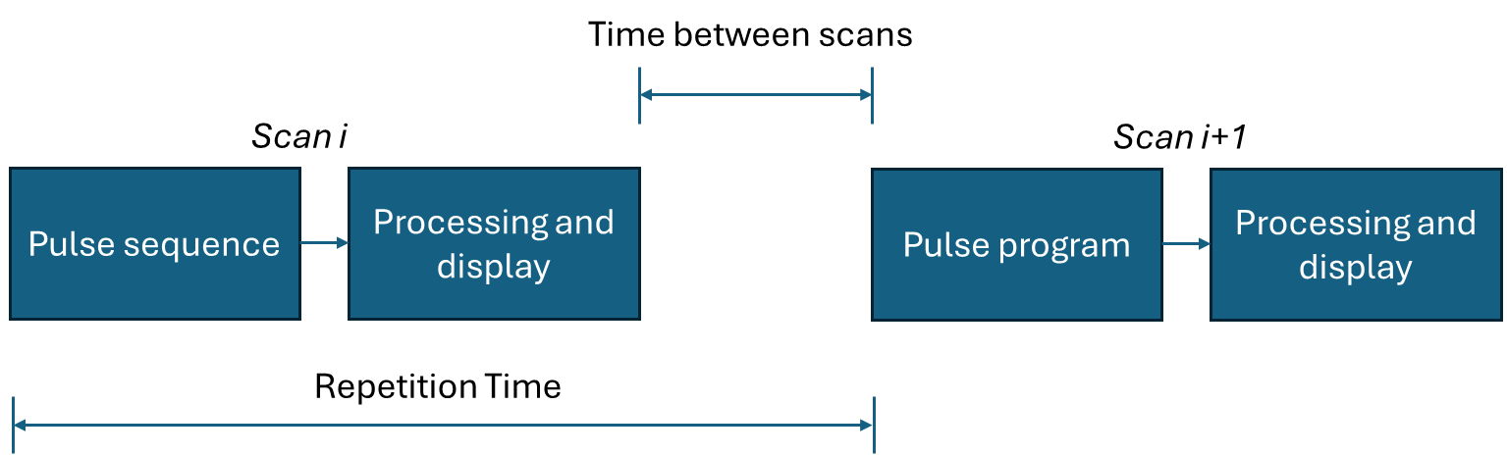

Experiments defined in this way have a very simple total duration equal to the number of scans multiplied by the repetition time. This can be quickly added to the expectedDuration procedure to control the progress bar e.g.

procedure(expectedDuration, guipar)

assignstruct(guipar)

totScans = nrScans + useStartDelay

duration = (totScans*repTime)/1000

endproc(duration)

In this procedure useStartDelay is an option to add an additional repetition time to the start of the experiment. Currently this is always 0.

Alternatively, you can define an interexperiment time, *ieTime*. This is the delay between the end of one pulse sequence scan and the start of the next.

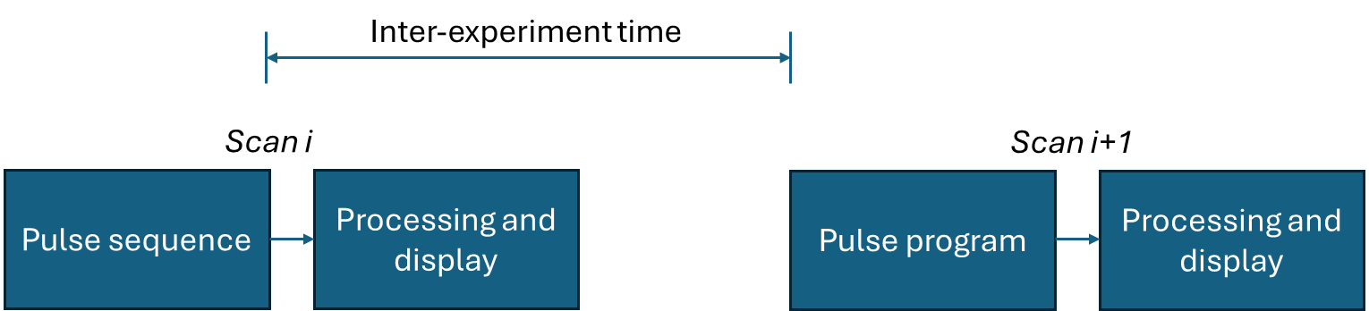

This is appropriate when the pulse sequence might have large variable delays such as T1. In this case, to determine the complete experiment duration you need to know the pulse sequence duration for each T1 step. The easiest way to determine this is to set up the experiment relationship list so it defaults to the shortest variable delay and then call the macro GetPulseProgramDuration to calculate the duration of a single pulse sequence execution with this short delay. Then take this result and add on the variable delay information. As an example, here is the expectedDuration procedure for the T1ie experiment

procedure(expectedDuration, guipar)

assignstruct(guipar)

if(delaySpacing == "log")

dArray = logspace(minDelay,maxDelay,nrSteps)*1000

else

dArray = linspace(minDelay,maxDelay,nrSteps)*1000

endif

totDelayTime = sum(dArray)+minDelay*1000 # Include dummy

nrDummys = 1

psTime = GetPulseProgramDuration("T1iet",1,guipar)*1000

psTime = psTime - minDelay*10000 # Base ps duration

psTime = psTime + nrPnts*10 # Data collection time estimate

totScans = (nrSteps+nrDummys)*nrScans

duration = (totScans*(psTime+ieTime*1000) + nrScans*totDelayTime)/1e6

endproc(duration)

Here we have duplicated the code for generating the duration array and then summed this to find the total delay time. This is then added to the base pulse program duration and then finally the interexperiment time is added. Note that there is some uncertainty in this calculation since we had to guess how long it takes to read the data back from the spectrometer. This can be corrected by explicitly calling the read command. For example see the experiment ProtonShowDetails.

In addition to the using the *ieTime* parameter instead of *repTime* and the more complex *expectedDuration* procedure, the other change is a relocation of the *ucsRun:checkTiming* procedure call in *execpp* and addition of a *tEndPS* variable which should be defined just before the start of the outer loop of the experiment and just after the *getData* procedure call.

Note that when using repTime it is necessary to make the repetition time long enough to include the longest pulse sequence time, plus the processing and display time. For ieTime cases the inter-experiment delay should always be longer than the processing and display time. If either of these statements is not true then the experiment will still proceed, but a warning will be written to the command line interface.

Spectrometer factory parameters

All Spinsolves are calibrated at the factory to optimise the performance of a variety of experiments. The necessary parameters are stored in Flash memory on the spectrometer and can be retrieved by the Expert software. Normally this happens automatically when you start the software with a spectrometer connected, if you reconnect using the *Select Spinsolve* option from the File menu or if you read the parameter directly in the *Spinsolve parameter dialog* again accessible from the file menu. These parameters are stored in the global data class gData and can be viewed in the CLI using the command

> print gData->specParameters

This will list all the parameters in their ‘raw’ form as stored on the spectrometer flash. This list includes the possibility for storing pulse information for up to 5 X nuclei. You can just access information for a particular nucleus using the command

> print gData->getXChannelParameters(nucleus)

Where nucleus is the string “13C” , “11B” etc. This will copy the appropriate pulse information for that channel into a series of standard variable names e.g. if X nucleus channel 3 is boron the power level will be copied from variable Power_level_X3 to Power_level_X. In this way you don’t need to know which X channel is which – just the nucleus name.

Following is a list of the most common variable names. These should be used in the getFactoryBasedParameters procedure in the pulse program macro to extract default factory parameters:

These define the single pulse X_channel parameters. Note that the frequency will be updated when performing a calibration:

X-channel pulse length ……… Pulse_length_X

X-channel pulse amplitude .. Power_level_X

X-channel frequency ………… Frequency_X

The following parameters define the amplitude of the proton pulse for different tip angles if the pulse length is the same as Pulse_length_X. This is used when applying a pulse to both the 1H and X channels simultaneously:

1H-X-45-Amplitude …………… Power_level_HX45

1H-X-90-Amplitude …………… Power_level_HX90

1H-X-135-Amplitude ……….… Power_level_HX135

1H-X-180-Amplitude ………… Power_level_HX180

The following parameters define the proton decoupling amplitude and pulse length as well as the NOE pulse amplitude

1H-decouple pulse length …. PulseLength_1H_Decouple

1H-decouple-amplitude ….… PowerLevel_1H_Decouple

1H-NOE pulse amplitude ..… PowerLevel_1H_NOE

In addition to the X-channel parameters there is also information about Proton and Fluorine:

1H 90 pulse length …………… PulseLength_1H

1H 90 pulse amplitude …...… PowerLevel_1H

1H Frequency …………………... Frequency_1H

19F 90 pulse length ………..… PulseLength_19F

19F 90 pulse amplitude ….… PowerLevel_19F

19F frequency ………………..… Frequency_Lock

These are the most important parameters. There are a few others which can be found in the Spinsolve Parameter dialog. Use the control-left click option on the appropriate text box to view the parameter names which can also be copied to the clip board.

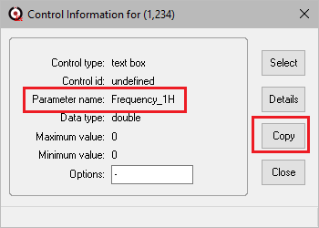

Apart from the frequencies and shim values all other parameters are quite stable and shouldn’t change significantly with temperature or time. The frequencies are of course updated using the lock and calibrate experiment while the various autoshimming tools keep the shims at the optimal values.

The SpinsolveExpert classes

The SpinsolveExpert software uses a series of global classes to simplify accessing variables and procedures from anywhere in the program. In this appendix we will just list some of the most commonly used variables and procedures which you might need to access in your experiment scripts. The classes are defined in the folder:

<expert_install_directory>\Macros\Spinsolve-Expert\Classes

and are macros starting with the prefix **se** (Spinsolve-expert). A single instance of each of these classes is then generated and the se prefix is replaced with **g** (for global). Note that with classes, member variables and member procedure are accessed using the arrow notation (->)

Class instances:

gBatch … this controls experiment batch processing

gData ….. this is where important data related to the experiment is stored and manipulated.

gExpt ….. this controls the experiment operation.

gFFT ….… contains code for data Fourier transformation.

gFX3 ……. controls the generation and execution of the event table on FX3 systems.

gLock …. controls finding the lock and displaying lock information.

gMenus . controls the addition and subtraction of user menus

gParam … this controls the construction of the Expert parameter list

gPlot …… control the layout of plots.

gProc …… this controls the post processing interface.

gSeq …… controls the generation and execution of the pulse programs for DSP systems.

gView ….. this class defines all the controls in the Expert interface.

In addition, there are a number of support macros in the Macros\UCS-Core folder which are used with the global classes and appear in all experiments. (e.g. ucsRun:getData)

Important data structures:

gData->specParameters .… the raw Spinsolve factory parameters

gData->curExpt ……………... information about the currently loaded experiment

gData->preferences ……….. user preferences.

gData->commonPar ……….. common parameters (b1Frequencies after calibration)

gView->gx ………………………. graph number x (1 … 6 1D plots, 7 … 10 2D plots)

Example class procedures

gData->getXChannelParameters(nucleus) …. returns the parameters specific to ‘nucleus’

gView->g**x**->subplot(1,1)->plot(x,y) …. Plots the x,y data into graph **x** subplot (1,1)

You can always print the class instances and substructures in the command line interface to get more information. E.g.

> pr gData->curExpt->parameters

This will print out all the parameters for the currently loaded experiment.

Pulse program limits

Here we list some limits on the various parameters using when pulse programming.

Maximum no. of events ………. Approximately 5000

Maximum data set size ……..… 174762 (this is 1024*1024/6, as each complex number requires 48 bytes, and 1 MByte of memory is available).

Maximum single table size1 .. 65534 (216-2)

Total table entries1……………….. 524272 (219-16)

Maximum RF amplitude …….. 0dB == ~1W or 16383 in digital units

Minimum RF amplitude ….….. -85 dB or 0 in digital units

Gradient range …………………… -32768 to 32767 (16-bit signed number)

Exporting to MNova

To allow a pulse program to export to MNova it is necessary to add a subfolder called MNova to the pulse program experiment folder in addition to the MNova post processing button. In this subfolder there should be several files:

logo.png ……………….. the logo to appear in the MNova plot.

protocol.mnova ….… the MNova layout template for this experiment.

protocol.mnp ……..… the MNova processing template for this experiment.

protocol.qs …………… a script file detailing how MNNova should handle the various files present in the data directory.

In this list ‘protocol’ is the name of the experiment (e.g. Proton or COSY).

It is beyond the scope of this document to describe the details of the .qs script file, but the easiest way to get this working is to use the option ‘New pulse program from existing file’ in the Pulse program editor and compiler interface. This will copy any existing MNova folder and will update the names of the MNova files. If you have chosen a similar experiment to duplicate, the MNnova export might work without any changes.

An introduction to Prospa programming

The entire SpinsolveExpert application is built on top of the Prospa programming environment. This is based around an interpreted language which is similar to Matlab, but with some significant differences.

When Prospa starts up it runs a script or macro which defines the user interface. If you run Prospa directly from the application folder, you will see an interface like this:

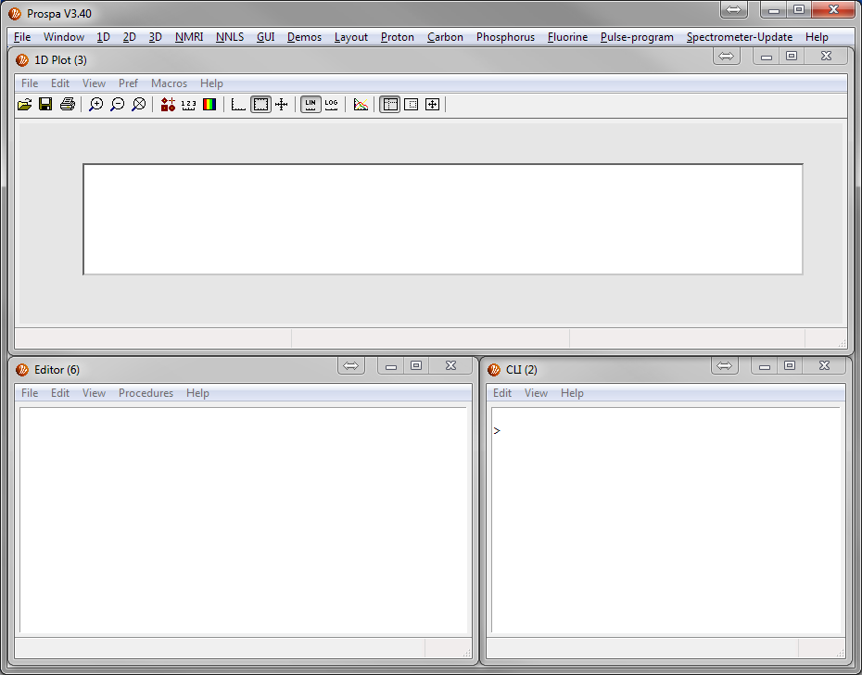

This consists of separate windows with simple functionality – a 1D plot, an editor and a command line interface. More complex interfaces can be designed (like SpinsolveExpert) which integrate these objects into the one window. (Also see the Layout menu for other possibilities).

The scripting langage is quite complex consisting of over 500 built in commands and more than 20 data types. However for the purposes of using the SpinsolveExpert interface only a fraction of these are needed.

Data types

The most important data types are:

string ................... double quoted text-based strings which may include escape characters.

Example: "A filename"

list ........................ arrays of strings. e.g ["string1","string2","string3"]

list2d . .................. jagged arrays of lists e.g. ["string11","string12", ... ; "string21","string22", ...]

float .. ................... 4 byte floating point numbers (the default number type) e.g. 3.14159

double .................. 8 byte floating point number e.g. 3.1415926535897931d

structure ............... a linked list of variables. e.g. s = struct(a=23, b = [1:10], c = "This is a test")

class ...................... like a structure but also support functions or procedures.

structure_array .... an array of structures e.g. s = struct(a=23, b = [1:10]; c = "This is a test", d= 2+3j; e = "_Another string"_, f = pi)

vector ................... 1D matrices - arrays of floats or doubles e.g. [1,2,3,4]

matrix ................... 2, 3 or 4 dimensional arrays of floats or doubles e.g. [1,2,3,4;5,6,7,8]

objects .................. user interface objects such as plots or text boxes. These can be interrogated to extract or set various parameters.

Variables

Data values are stored in variables. This is done using an assignment statement e.g.

myVector = [1,2,3,4]

Note that the vector name can be any length (although shorter names are interpreted faster), are case sensitive, and may include numbers as long as the resultant name is not a valid number. (So 1Pulse is a valid variable name!)

Variables can be collected together in structures. To define a structure, use the syntax

s = struct()

s->pi = 3.1415926

s->vec = [1,2,3,4,5]

or more simply

s = struct(pi=3.1415926, vec=[1,2,3,4,5])

in a procedure, local variables can be converted to a list using the command:

lst = mkparlist()

This takes all local variables (see below) and packs them into a string list. Note that you can't include objects or 3D or 4D matrices in list. Other matrices should be small. The alternative which does allow this is a structure (mkparstruct).

To convert a string list into local variables use the reverse command

assignlist(lst)

This also works for structures.

Variables defined on the command line interface have global scope (i.e. they are accessible everywhere.) Variables defined inside a procedure (see below) have local scope and are only accessible from within the procedure. It is also possible to have variables with window scope which are accessible from all children of the parent window.

Control statements

Prospa supports the following control statements. Syntax is fairly standard.

if-elseif-else-endif

while-exitwhile-endwhile

for-exitfor-next

Please refer to the Prospa documentation for details (type F1 when the cursor is on the command).

Procedures

Prospa scripts are typically broken into procedures (i.e. functions) which are blocks of code surrounded by the statements

procedure(name, arguments)

...

endproc(return_values)

Note that multiple values can be returned from a procedure. To exit early from a procedure use the return command.

To call a procedure from within the current file (which should have the extension .mac – for macro or .pex for prospa executable macro), use the following syntax

result = :myProc(arg1, arg2)

To call a procedure in another file just add the filename

result = filename:myProc(arg1,arg2)

The extension need not be included, as .mac (or .pex) is assumed.

To return multiple values place them in parenthesis and use commas to delimit them:

(result1,result2) = :procName(arg1,arg2,arg3)

All variables defined in a procedure have local scope i.e. they are not visible outside the procedure.

Please refer to the Prospa manual for more details about using procedures.

Commands

Some 500 predefined commands are included in the Prospa package. A list can be obtained using the listcom command. These commands are written in C++ and so are generally much faster than using explicit low level prospa commands. Check the help viewer accessible from the Help menu to see a list of these.

The syntax is exactly as it is for procedures

result = command(arg1, arg2, ...)

or

(result1,result2 ...) = command(arg1, arg2, ...)

These commands include functions to manipulate data types, access the file system and build user interfaces.

Debugging

You can test the various commands and syntax by typing them into the command line interface. Use the print (pr) command to print results. e.g.

> a = 2^4

> pr a

a = 16

Expressions

Commands, variables and procedures may be combined in expressions where the syntax is valid. e.g.

magnitude = sqrt(x^2+y^2)

Standard mathematical precedence is followed. Note that if a command with multiple return values appears in the expression only the first return value is used. If you want to extract the nth returned value use the *retvar* command (1 based).

Matrices and vectors

Both real and complex vectors and matrices can be defined. To define a blank matrix of dimensions 1,2,3,4 use the following synax

mat = matrix(dim1, dim2, dim3, dim4)

Where dimx is the size of the xth dimension. Note that for 2 and 3D matrices the dimension order is x, y, z ***not*** row, col , depth as it is in Matlab and other languages. This syntax is also used when accessing elements

result = mat[x,y,z].

To define a linear 1D vector use the following syntax

result = [start:step:end] (step is optional)

or

resut = linspace(start,end,number)

To access the first element use the index ***0*** while to access last element use the index ***-1*** (the second to last -2 etc). e.g

lastValue = vec[-1]

To access some elements in the vector use this syntax

subvector = vec[start:step:end]

This will include all values in ‘vec’ between indicies start and end but with a ‘step’ between each value.

All elements in one dimension can be signified with a tilde ‘~’ or colon ‘:’ e.g. to extract the yth row from a 2D matrix:

row = mat[~,y]

To get the dimensions of a matrix use the size command

(width, height) = size(mat)

User interface objects

User interface ojbects such as buttons, text boxes, plots etc. can be assigned to object variables. They can then be used to access functions and variables embedded in the objects.

Access is done via the arrow operator e.g. for the SpinsolveExpert interface

plt1 = gView->g1->subplot(1,1)

plt1->plot(x,y)

(x,y) = plt1->getdata()

The first command access the first plot in the Expert interface which is defined in the gView class instance. The second command plots the x-y pair in the first region plt1 of plot/graph control g1. The third command extracts the x-y data from the plot.

To see the commands and variables available for an object just type the object name into the command line interface. Help is also available in the classes topic in the help viewer.

> pr plt1

#### 1D plot-region object ####

PARAMETER VALUE

antialiasing1d..... "true"

autorange ......... "true"

axes .............. object

bordercolor ....... [230,230,230]

bkgcolor .......... [255,255,255]

clear ............. cmd : clear all trace data

dim ............... "1d"

draw .............. "true"

filename .......... "image_section.pt1"

filepath .......... "C:\ ... \Example Data\Plots\"

fileversion ....... 1.4

getdata ........... cmd : extract (x,y) data

grid .............. object

hold .............. "false"

load .............. cmd : load a pt1 file into plot region

parent ............ control: 1

plot ............. cmd : display (x,y) data

position .......... (1,1)

border ............ "true"

save .............. cmd : save plot region contents to a pt1 file

trace ............. object

tracelist ......... cmd : return array of trace id numbers

tracepref ......... cmd : set or get trace drawing preferences

title ............. object

xlabel ............ object

ylabel ............ object

zoom .............. cmd : set viewing limits

Using the Prospa text editor

If you develop Prospa scripts inside the Prospa editor then you will get some additional features compared with writing it in a simple editor such as Notepad. A Prospa editor is available from the Expert Windows menu. Here are some of the editor features:

1. Syntax coloring. Different types of commands are colored differently.
2. Syntax hints. As you type a command the valid arguments are listed in the editor status box.
3. Help. Pressing F1 when the cursor is on a command will display detailed help and often an example.
4. Procedure searching. Using the editor menus or keyboard shortcuts you can jump to and from Procedure code.
5. Indenting and commenting. The editor menu has commands to rapdily comment and indent block of selected code.
6. Code execution. Stand-alone macros in the editor can be executed using the shortcut Ctrl-R.

Additional help

Additional Prospa help can be found in the document:

Prospa programming manual.pdf

These files can be found in the Expert/Prospa install directory in the folder:

"PDF Documentation".

Help can be found in the Viewer found in the main Help menu.

Last modified 25-November-2024 by Craig Eccles

1. A 1D list can be used, but it requires two addition parameters per row which are only used in the V3 legacy interface. Some experiments still use the 1D list.
2. See the pulse program commands section.